Supplemental Fig.1 Through bioinformatics analysis, we found some genes related to estrogen and diabetes.
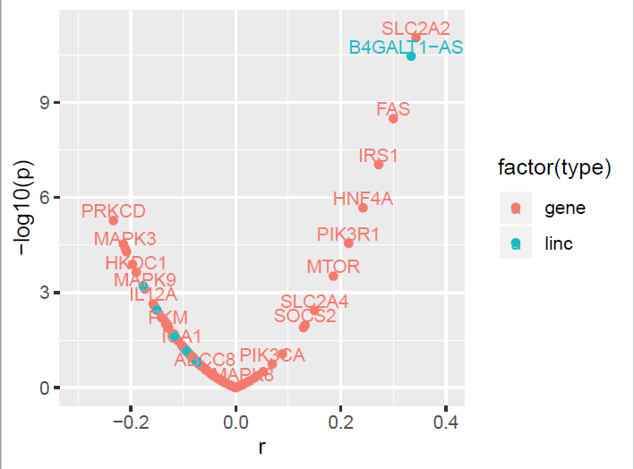
Supplemental Fig.1 Through bioinformatics analysis, we found some genes related to estrogen and diabetes. (A) Genes and ncRNAs related to diabetes were obtained and calculated the correlation with ER α in TCGA liver cancer dataset.

Supplemental Fig.2 Quercetin can significantly increase B4GALT1-AS1 expression in estrogen and diabetes-related genes.
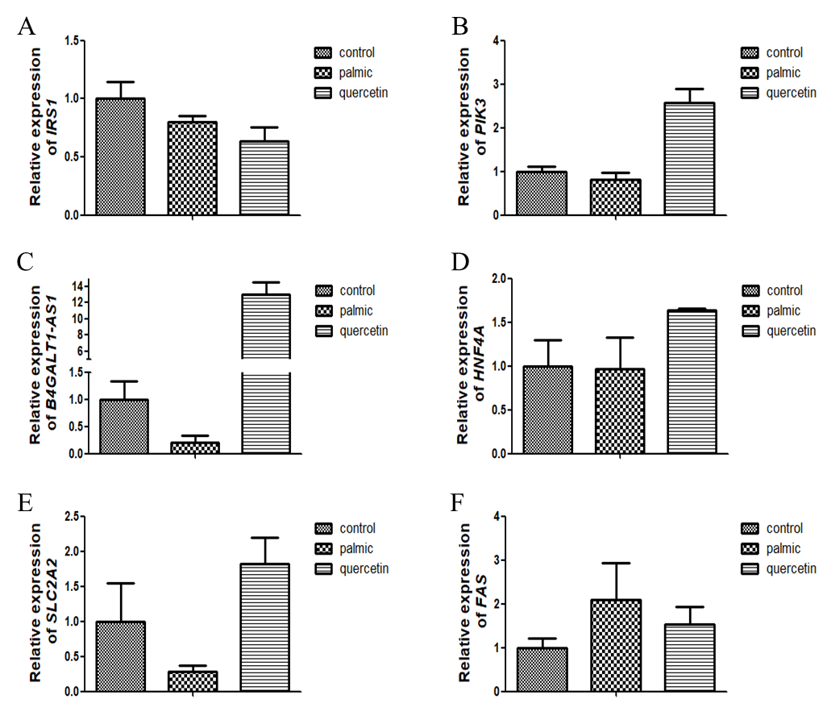
Supplemental Fig.2 Quercetin can significantly increase B4GALT1-AS1 expression in estrogen and diabetes-related genes. (A) IRS1 expression in HepG2 (n = 5), (B) PIK3 expression in HepG2 (n = 5), (C) B4GALT1-AS1 expression in HepG2 (n = 5), (D) HNF4A expression in HepG2 (n = 5), (E) SLC2A2 expression in HepG2 (n = 5) and (F) FAS expression in HepG2 (n = 5).

Supplemental Fig.3 Quercetin can significantly increase LncSHGL expression in estrogen and diabetes-related genes.
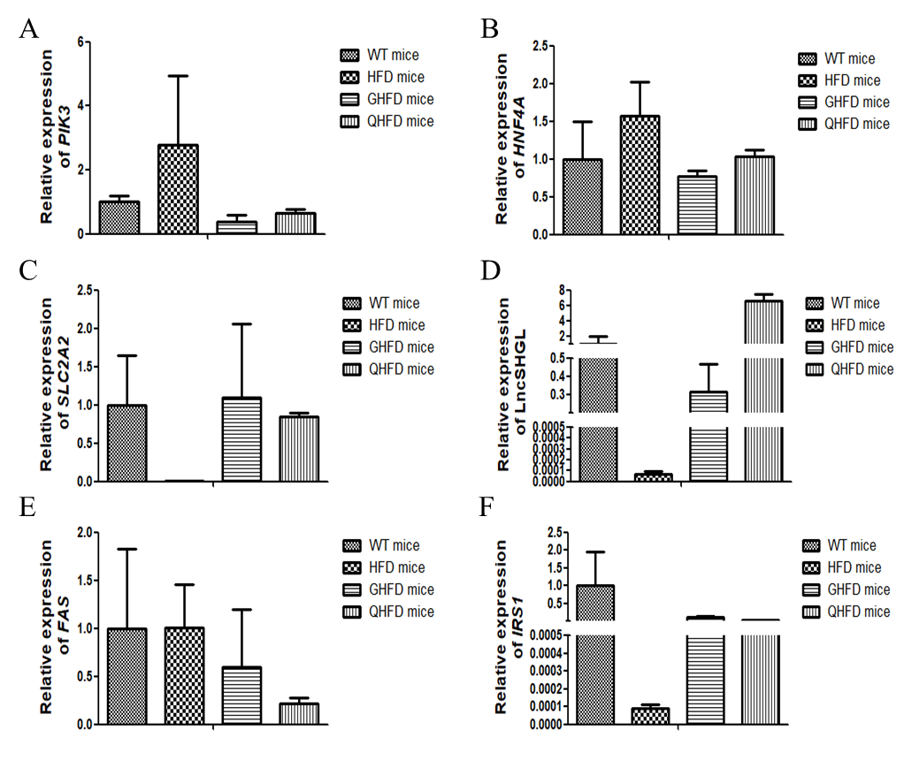
Supplemental Fig.3 Quercetin can significantly increase LncSHGL expression in estrogen and diabetes-related genes. (A) PIK3 expression in mice liver (n = 4), (B) HNF4A expression in mice liver (n = 4), (C) SLC2A2 expression in mice liver (n = 4), (D) lncSHGL expression in mice liver (n = 4), (E) FAS expression in mice liver (n = 4) and (F) IRS1 expression in mice liver (n = 4).

Supplementary table 1 Genes and ncRNAs related to diabetes were obtained and calculated the correlation with ER α in TCGA liver cancer dataset
ensg | symbol | ensg_id | r | p
ENSG00000145675 | PIK3R1 | ENSG00000145675.13 | 0.2149 | 2.79E-05
ENSG00000101076 | HNF4A | ENSG00000101076.15 | 0.2423 | 2.12E-06
ENSG00000169047 | IRS1 | ENSG00000169047.5 | 0.272 | 9.14E-08
ENSG00000026103 | FAS | ENSG00000026103.18 | 0.3 | 3.22E-09
ENSG00000233554 | B4GALT1-AS1 | ENSG00000233554.4 | 0.3339 | 3.44E-11
ENSG00000163581 | SLC2A2 | ENSG00000163581.12 | 0.3431 | 8.97E-12

